Student Performance Prediction System

Project Id: AIML-6

Name : Nakshatra Agarwal (Team Leader)
Class Roll Number:55
University Roll Number :2028775
Section and Group: P G2

Name : Manvi Arora
Class Roll Number:52
University Roll Number : 2028761
Section and Group: P G2

Name : Ruhee Gupta
Class Roll Number:63
University Roll Number : 2028829
Section and Group: P G2

- Problem Description 3
- Architecture 4
- Models model 5
- Evaluation metrics used 6
- Preliminary Results and Visualizations 7
- References 8

- Problem Description
- Urban water demand varies significantly due to factors such as household size, seasonal conditions, and outdoor water usage like gardening. Accurately predicting daily water consumption is essential for efficient resource allocation, reducing wastage, and ensuring sustainable urban planning. However, traditional estimation approaches often fail to capture these dynamic relationships and variations present in real-world data.
- This project focuses on developing a data-driven predictive model to estimate daily water usage using a curated dataset containing features such as Household_Size, Seasonal_Index, and Garden_Area. The dataset includes realistic characteristics such as missing values and variability, requiring preprocessing techniques like data cleaning and outlier handling to ensure data quality.
- Feature scaling using StandardScaler is applied to normalize the data, enabling fair contribution of all features during model training. A Linear Regression algorithm is then used to model the relationship between input variables and the target variable, Daily_Liters_Used. The model’s performance is evaluated using statistical metrics and residual analysis to ensure reliability and accuracy.
- The outcome of this project provides insights into water consumption patterns and demonstrates how machine learning can support efficient water resource management in urban environments.

- Architecture

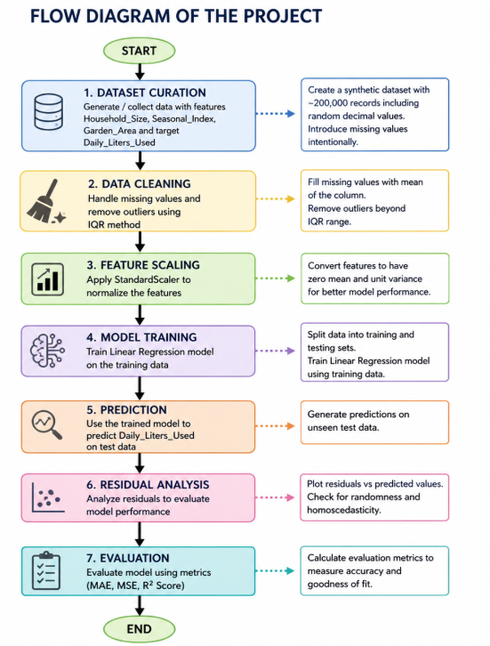

- Models Used(Applied/ Planned) Give a brief introduction of the models used

1. Pandas
Pandas is used for data manipulation and analysis. It helps in reading, organizing, and cleaning the dataset using DataFrame structures.

2. NumPy
NumPy is used for numerical computations and handling arrays efficiently. It supports mathematical operations required during data processing.

3. Scikit-learn (sklearn)
Scikit-learn is the primary machine learning library used in this project. It provides tools for:
- Feature scaling using StandardScaler
- Splitting data using train_test_split
- Implementing models like Linear Regression, Decision Tree, Random Forest, and SVR
- Evaluating model performance

4. StandardScaler
StandardScaler is used to normalize the dataset so that all features have equal importance during model training.

5. Linear Regression and Other Models
Different regression models such as Linear Regression, Decision Tree Regressor, Random Forest Regressor, and Support Vector Regression are applied to predict daily water usage and compare performance.

6. Matplotlib and Seaborn
These libraries are used for data visualization, including plotting graphs like correlation heatmaps, prediction plots, and residual analysis.
- Evaluation metrics used
To evaluate the performance of the machine learning models, several regression metrics are used. These metrics help measure how accurately the model predicts daily water consumption.

1. Mean Absolute Error (MAE)
MAE calculates the average absolute difference between actual and predicted values.
$$MAE=\frac{1}{n}∑∣y-\hat{y}∣$$
Interpretation:
- Gives average prediction error in liters
- Lower MAE indicates better model performance

2. Mean Squared Error (MSE)
MSE calculates the average of squared differences between actual and predicted values.
$$MSE=\frac{1}{n}∑(y-\hat{y})^{2}$$
Interpretation:
- Penalizes larger errors more
- Lower MSE indicates better accuracy

3. Root Mean Squared Error (RMSE)
RMSE is the square root of MSE and represents error in the original unit.
$$RMSE=\sqrt{MSE}$$
Interpretation:
- More interpretable than MSE
- Lower RMSE indicates better model

4. R² Score (Coefficient of Determination)
R² measures how well the model explains the variation in the data.
$$R^{2}=1-\frac{∑(y-\hat{y})^{2}}{∑(y-\overset{ˉ}{y})^{2}}$$

5. Preliminary Results and Visualizations

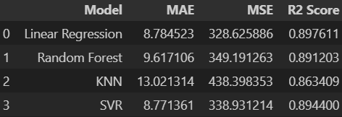
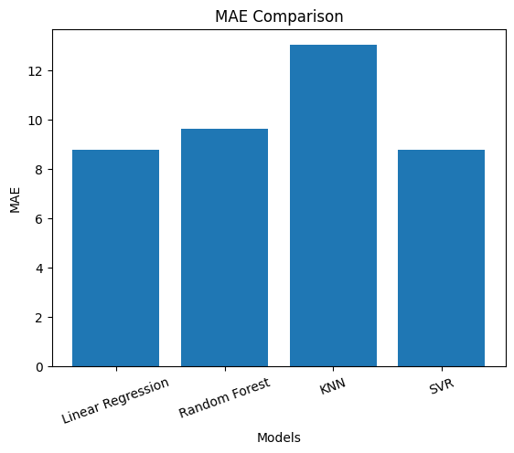
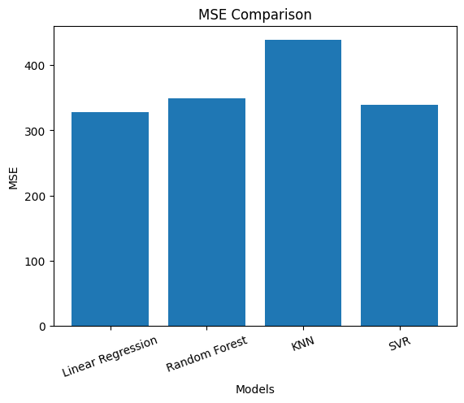
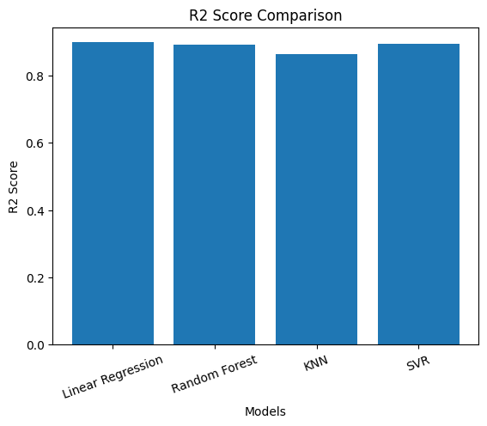
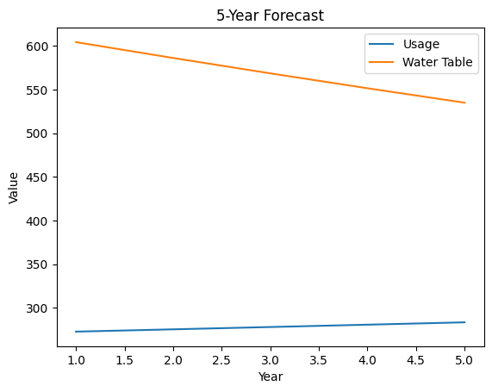
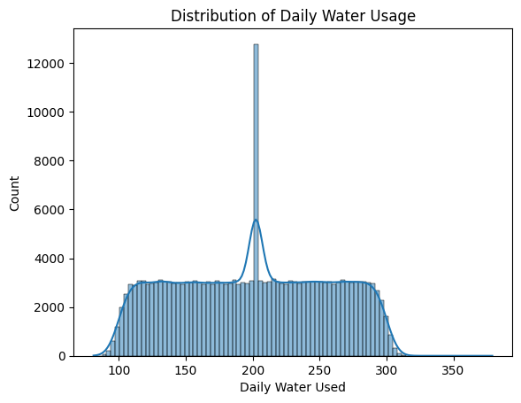
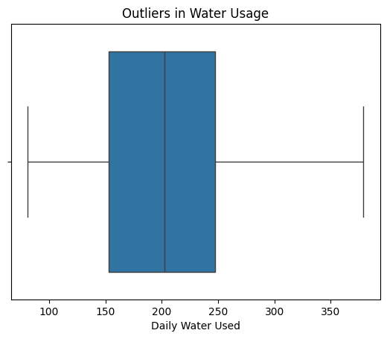

6. References:
Books:
- Let Us Python – Yashavant Kanetkar

Online Resources:
  - GeeksforGeeks – https://www.geeksforgeeks.org/
  - TutorialsPoint – https://www.tutorialspoint.com/cprogramming/index.htm
  - Stack Overflow – https://stackoverflow.com

